JFS-TASK -5

QUESTION 1

1.Write a program using map( ) method, to convert a list of Strings into uppercase. If the given List is: Stream names = Stream.of("aBc", "d", "ef");

**Code:**

package Module_1.Day_15;  
  
import java.util.*;  
import java.util.stream.Collectors;  
import java.util.stream.Stream;  
  
public class Question1 {  
 public static void main(String[] args) {  
 Stream<String> names = Stream.*of*("aBc", "d", "ef");  
  
 List<String> uppercaseNames = names  
 .map(String::toUpperCase)  
 .collect(Collectors.*toList*());  
  
 System.*out*.println(uppercaseNames);  
 }  
}

**output screen shot:**

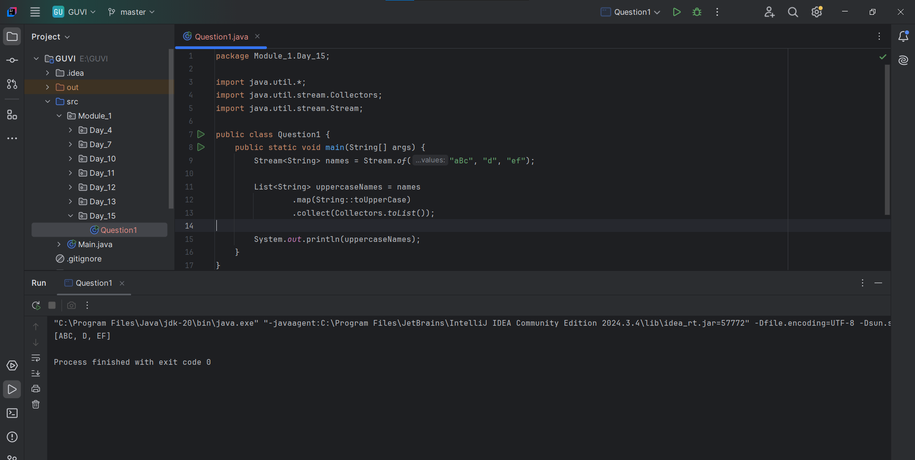

**Question 2:**

2. Write a program to check whether the Strings in the List are empty or not and print the list having non-empty strings. If the given List is: List strings = Arrays.asList("abc", "", "bc", "efg", "abcd", "", "jkl");

Code:

package Module_1.Day_15;  
  
import java.util.Arrays;  
import java.util.List;  
import java.util.stream.Collectors;  
  
public class Question2  
{  
 public static void main(String[] args) {  
 List<String> Values = Arrays.*asList*("abc", "", "bc", "efg", "abcd", "", "jkl");  
  
 List<String> nonEmptyValues= Values.stream()  
 .filter(s -> !s.isEmpty())  
 .collect(Collectors.*toList*());  
  
 System.*out*.println(nonEmptyValues);  
 }  
}

output screen shot:

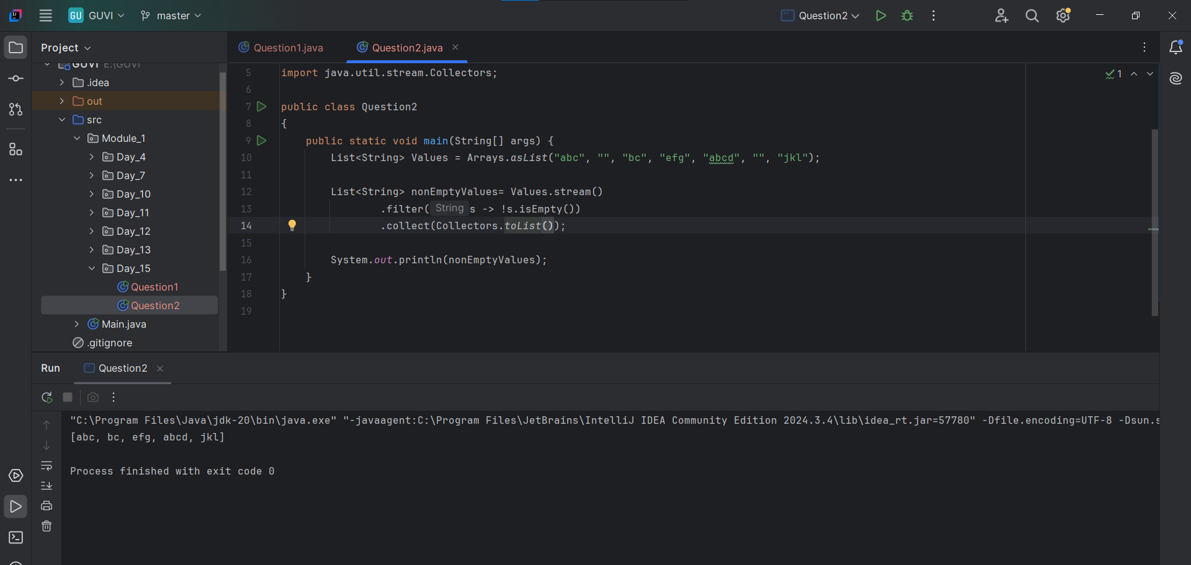

**Question 3:**

3. You are a teacher in school. In your class there are 10 students, you have decided to give special gifts to those students whose names start with “A”. You are asked to separate those students with the help of a Java program.

Requirement:

Use List interface to store the student name

Use a lambda expression and the Stream API to filter the students

**Code:**

package Module_1.Day_15;  
  
import java.util.Arrays;  
import java.util.List;  
import java.util.stream.Collectors;  
  
public class Question3 {  
 public static void main(String[] args) {  
 List<String> students = Arrays.*asList*("Alice", "Bob", "Andrew", "Charlie", "Ava");  
  
 // Filtering students whose names start with "A"  
 List<String> studentsWithA = students.stream()  
 .filter(name -> name.startsWith("A"))  
 .toList();  
  
 // Printing  
 System.*out*.println("Students receiving special gifts: " + studentsWithA);  
 }  
}

output screen shot:

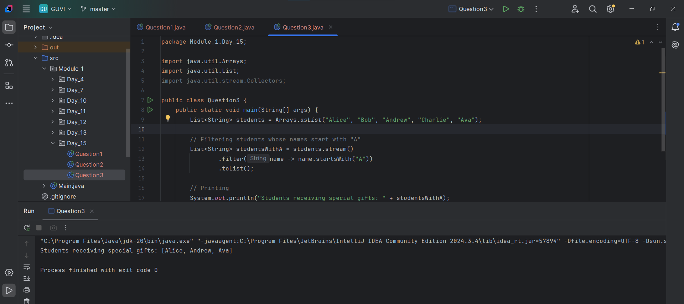

**Question 4:**

4. Rajesh has been given a task to create an app which takes the user's birthdate as input and calculates their age, you have to help him to build this app using the java.time.LocalDate class.

Input:

Enter your birthdate (yyyy-mm-dd): 1990-05-15

Output:

Your age is: 33 years, 4 months, and 13 days.

Code:

package Module_1.Day_15;  
  
import java.time.LocalDate;  
import java.util.Scanner;  
import java.time.Period;  
  
public class Question4 {  
 public static void main(String[] args) {  
 Scanner input = new Scanner(System.*in*);  
  
 // Taking user input for birthdate  
 System.*out*.print("Enter your birthdate (yyyy-mm-dd): ");  
 String dateofbirth = input.nextLine();  
  
 // Parsing input date to LocalDate  
 LocalDate birthDate = LocalDate.*parse*(dateofbirth);  
 LocalDate currentDate = LocalDate.*now*();  
  
 // Calculating the age using Period  
 Period age = Period.*between*(birthDate, currentDate);  
  
 // Displaying the result  
 System.*out*.println("Your age is: " + age.getYears() + " years, " +  
 age.getMonths() + " months, and " +  
 age.getDays() + " days.");  
  
 input.close();  
 }  
}

output screen shot  
